

subnetting ip networks

Introduction to Networking and Security



November 10, 2019

Jamie lu

W0441213

Table of Contents

Introduction: 2

Question 2 3

Activity 8.1.4.7 3

SCREENSHOT 1 OF ACTIVITY 8.1.4.7 6

SCREENSHOT 2 OF ACTIVITY 8.1.4.7 7

SCREENSHOT 3 OF ACTIVITY 8.1.4.7 8

Question 3 9

Question 4 9

Question 5 10

Activity 8.2.1.4 10

SCREENSHOT 1 OF ACTIVITY 8.2.1.4 12

SCREENSHOT 2 OF ACTIVITY 8.2.1.4 13

Question 6 14

Activity 8.3.1.4 14

SCREENSHOT 1 OF ACTIVITY 8.3.1.4 15

SCREENSHOT 2 OF ACTIVITY 8.3.1.4 16

SCREENSHOT 3 OF ACTIVITY 8.3.1.4 17

Question 7 18

Activity 8.4.1.2 18

SCREENSHOT 1 OF 8.4.1.2 19

SCREENSHOT 2 OF 8.4.1.2 20

SCREENSHOT 3 OF 8.4.1.2 21

SCREENSHOT 4 OF 8.4.1.2 22

SCREENSHOT 5 OF 8.4.1.2 23

SCREENSHOT 6 OF 8.4.1.2 24

SCREENSHOT 7 OF 8.4.1.2 25

SCREENSHOT 8 OF 8.4.1.2 26

References 27

Appendix 28

Appendix A – Cisco Commands Tool Kit 28

# Introduction:

This assignment contains activities that used learnings from Cisco’s CCNA R&S: Introduction to Networking: Chapters 8[1], as well as, useful information from the Cisco IOS Configuration Fundamentals Command Reference[2]. This assignment also contains the continued information learned and skills acquired with regards to the topics that were covered in previous chapters and in Chapter 8, specifically, subnetting, VLSM, and IPv6 design.

# Question 2

## Activity 8.1.4.7

Part 1: Step 1:

a. Based on the topology, how many subnets are needed?

- Based on the topology, 5 subnets are needed.

b. How many bits must be borrowed to support the number of subnets in the topology table?

- 3 bits must be borrowed to support the number of subnets in the topology table.

c. How many subnets does this create?

- This creates 8 subnets (23 = 8)

d. How many usable hosts does this create per subnet?

- This creates 30 usable hosts per subnet.

e. Calculate the binary value for the first five subnets.

Net 0: 192 . 168 . 100 . 0 0 0 0 0 0 0 0

Net 1: 192 . 168 . 100 . 0 0 1 0 0 0 0 0

Net 2: 192 . 168 . 100. 0 1 0 0 0 0 0 0

Net 3: 192 . 168 . 100. 0 1 1 0 0 0 0 0

Net 4: 192 . 168 . 100. 1 0 0 0 0 0 0 0

f. Calculate the binary and decimal value of the new subnet mask.

11111111.11111111.11111111.11100000

255 255 255 (128+64+32 = 224)

255.255.255.224

g. Fill in the Subnet Table, listing the decimal value of all available subnets, the first and last usable host address, and the broadcast address. Repeat until all addresses are listed

|  |  |  |  |  |
| --- | --- | --- | --- | --- |
| Subnet Number | Subnet Address | First Usable Host Address | Last Usable Host Address | Broadcast Address |
| 0 | 192.168.100.0 | 192.168.100.1 | 192.168.100.30 | 192.168.100.31 |
| 1 | 192.168.100.32 | 192.168.100.33 | 192.168.100.62 | 192.168.100.63 |
| 2 | 192.168.100.64 | 192.168.100.65 | 192.168.100.94 | 192.168.100.95 |
| 3 | 192.168.100.96 | 192.168.100.97 | 192.168.100.126 | 192.168.100.127 |
| 4 | 192.168.100.128 | 192.168.100.129 | 192.168.100.158 | 192.168.100.159 |
| 5 | 192.168.100.160 | 192.168.100.161 | 192.168.100.190 | 192.168.100.191 |
| 6 | 192.168.100.192 | 192.168.100.193 | 192.168.100.222 | 192.168.100.223 |
| 7 | 192.168.100.224 | 192.168.100.225 | 192.168.100.254 | 192.168.100.255 |
| 8 |  |  |  |  |
| 9 |  |  |  |  |
| 10 |  |  |  |  |

Step 2:

a. Assign Subnet 0 to the LAN connected to the GigabitEthernet 0/0 interface of R1:

- 192.168.100.0/27

b. Assign Subnet 1 to the LAN connected to the GigabitEthernet 0/1 interface of R1:

- 192.168.100.32/27

c. Assign Subnet 2 to the LAN connected to the GigabitEthernet 0/0 interface of R2:

- 192.168.100.64/27

d. Assign Subnet 3 to the LAN connected to the GigabitEthernet 0/1 interface of R2:

- 192.168.100.96/27

e. Assign Subnet 4 to the WAN link between R1 to R2:

- 192.168.100.128/27

**ADDRESSING SCHEME**

|  |  |  |  |  |
| --- | --- | --- | --- | --- |
| **Device** | **Interface** | **IP Address** | **Subnet Mask** | **Default Gateway** |
| R1 | G0/0 | 192.168.100.1 | 255.255.255.224 | N/A |
| G0/1 | 192.168.100.33 | 255.255.255.224 | N/A |
| S0/0/0 | 192.168.100.129 | 255.255.255.224 | N/A |
| R2 | G0/0 | 192.168.100.65 | 255.255.255.224 | N/A |
| G0/1 | 192.168.100.97 | 255.255.255.224 | N/A |
| S0/0/0 | 192.168.100.158 | 255.255.255.224 | N/A |
| S1 | VLAN 1 | 192.168.100.2 | 255.255.255.224 | 192.168.100.1 |
| S2 | VLAN 1 | 192.168.100.34 | 255.255.255.224 | 192.168.100.33 |
| S3 | VLAN 1 | 192.168.100.66 | 255.255.255.224 | 192.168.100.65 |
| S4 | VLAN 1 | 192.168.100.98 | 255.255.255.224 | 192.168.100.97 |
| PC1 | NIC | 192.168.100.30 | 255.255.255.224 | 192.168.100.1 |
| PC2 | NIC | 192.168.100.62 | 255.255.255.224 | 192.168.100.33 |
| PC3 | NIC | 192.168.100.94 | 255.255.255.224 | 192.168.100.65 |
| PC4 | NIC | 192.168.100.126 | 255.255.255.224 | 192.168.100.97 |

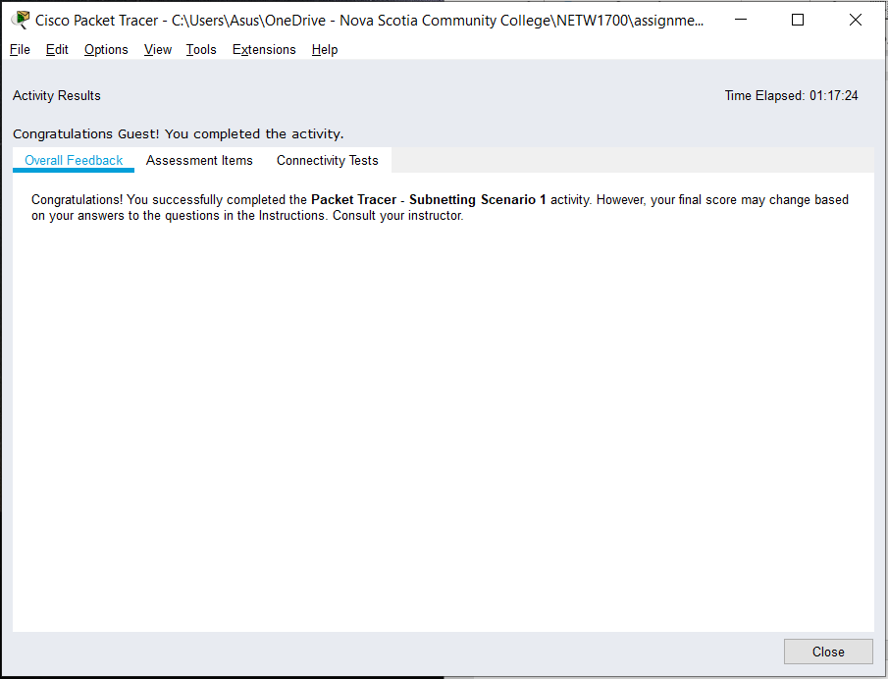

### SCREENSHOT 1 OF ACTIVITY 8.1.4.7

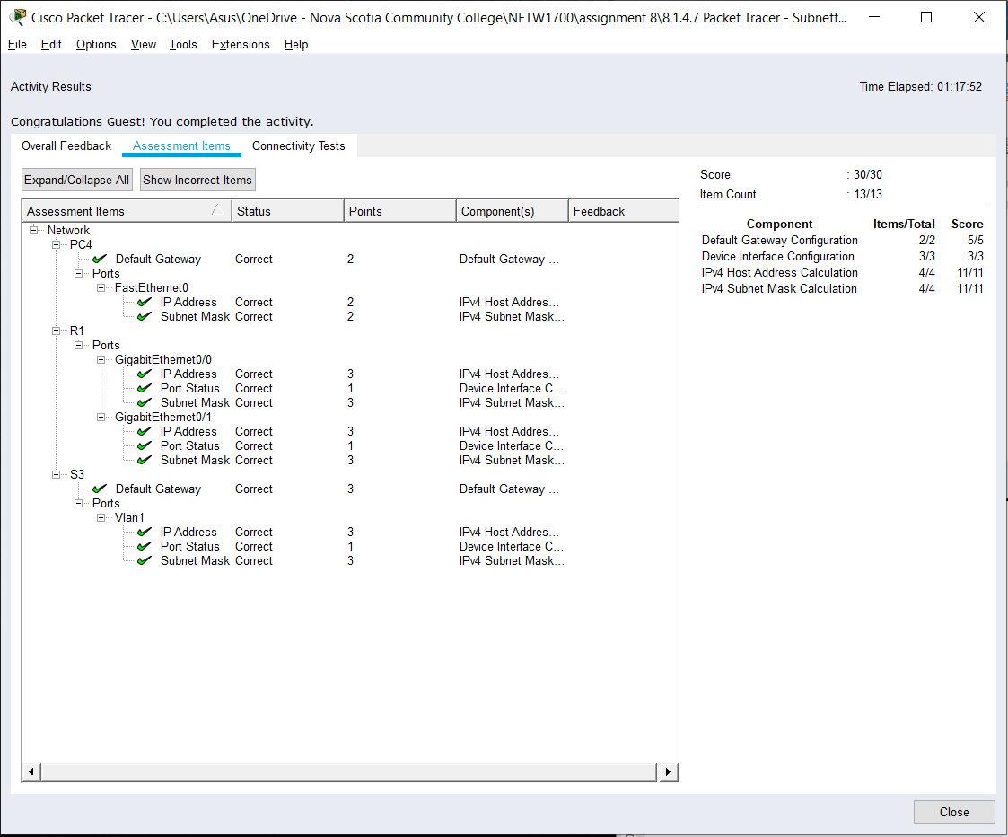

### SCREENSHOT 2 OF ACTIVITY 8.1.4.7

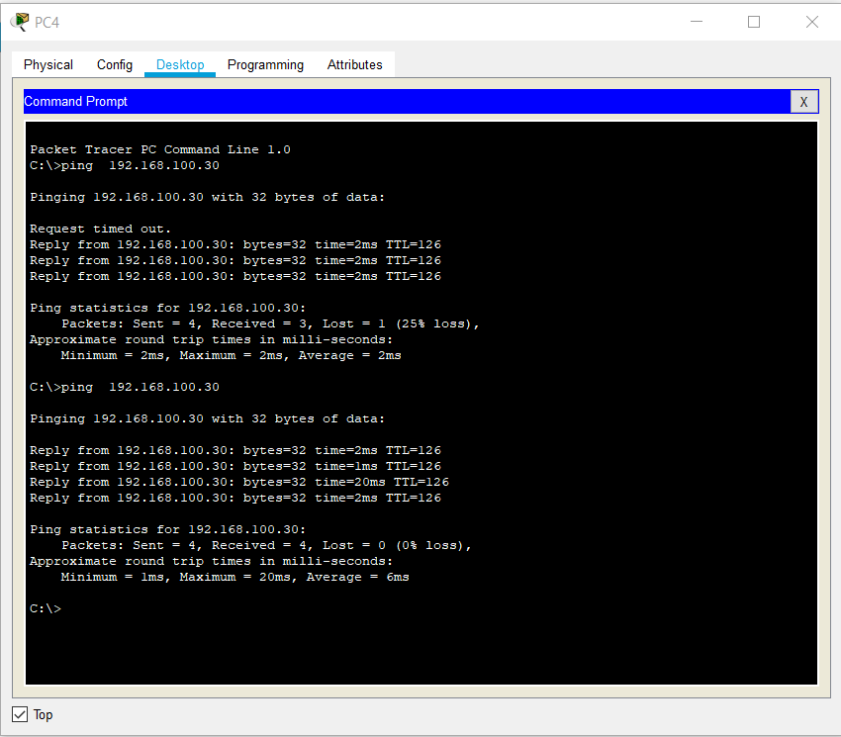

### SCREENSHOT 3 OF ACTIVITY 8.1.4.7

# Question 3

First Name: **J** Last Name: **L**

Network Address: Number of Nodes/Hosts Required:

**132.117.1.0 29**

# Question 4

a. What is the default subnet mask?

- The default subnet mask is 255.255.0.0 because it is part of Class B

b. What subnet mask is required to supply the required number of nodes per network?

- 132.117.1.0/27 255.255.255.224

c. How many nodes are actually created?

- There are 32 nodes actually created.

d. How many new networks are created?

- 2048 nodes are created

e. What are the first 2 and last 2 networks created?

- 132.117.1.0 and 132.117.1.32 are the first 2 networks created

- 132.117.1.192 and 132.117.1.224 are the last 2 networks created

f. What is broadcast address of the first and last network created?

-132.117.1.31 is the broadcast address of the first network created and 132.117.1.255 is the broadcast address of the last network created

128 64 32 16 8 4 2 1 --- magic number

2 4 8 16 32 64 128 256 --- represents network

256 128 64 32 16 8 4 2 --- hosts (u gotta -2)

/25 /26 /27 /28 /29 /30 /31 /32 --- CIDR (start 32 🡨)

|  |  |  |
| --- | --- | --- |
| **Network Address** | **Usable Host Range** | **Broadcast Address:** |
| 132.117.1.0 | 132.117.1.1 - 132.117.1.30 | 132.117.1.31 |
| 132.117.1.32 | 132.117.1.33 - 132.117.1.62 | 132.117.1.63 |
| 132.117.1.64 | 132.117.1.65 - 132.117.1.94 | 132.117.1.95 |
| 132.117.1.96 | 132.117.1.97 - 132.117.1.126 | 132.117.1.127 |
| 132.117.1.128 | 132.117.1.129 - 132.117.1.158 | 132.117.1.159 |
| 132.117.1.160 | 132.117.1.161 - 132.117.1.190 | 132.117.1.191 |
| 132.117.1.192 | 132.117.1.193 - 132.117.1.222 | 132.117.1.223 |
| 132.117.1.224 | 132.117.1.225 - 132.117.1.254 | 132.117.1.255 |

# Question 5

## Activity 8.2.1.4

Part 1: Step 1:

How many subnets are needed in the network topology?

- There are 5 subnets needed in the network topology.

Step 2:

a. Which subnet mask will accommodate the number of IP addresses required for ASW-1?

- 255.255.255.240/28

How many usable host addresses will this subnet support?

- 14

b. Which subnet mask will accommodate the number of IP addresses required for ASW-2?

- 255.255.255.224/27

How many usable host addresses will this subnet support?

- 30

c. Which subnet mask will accommodate the number of IP addresses required for ASW-3?

- 255.255.255.248/29

How many usable host addresses will this subnet support?

- 6

d. Which subnet mask will accommodate the number of IP addresses required for ASW-4?

- 255.255.255.192/26

How many usable host addresses will this subnet support?

- 62

e. Which subnet mask will accommodate the number of IP addresses required for the connection between Building1 and Building2?

- 255.255.255.252/30

**ADDRESSING SCHEME**

|  |  |  |  |  |
| --- | --- | --- | --- | --- |
| **Device** | **Interface** | **IP Address** | **Subnet Mask** | **Default Gateway** |
| Building1 | G0/0 | 10.11.48.97 | 255.255.255.240 | N/A |
| G0/1 | 10.11.48.65 | 255.255.255.224 | N/A |
| S0/0/0 | 10.11.48.121 | 255.255.255.252 | N/A |
| Building2 | G0/0 | 10.11.48.113 | 255.255.255.248 | N/A |
| G0/1 | 10.11.48.1 | 255.255.255.192 | N/A |
| S0/0/0 | 10.11.48.122 | 255.255.255.252 | N/A |
| ASW-1 | VLAN 1 | 10.11.48.98 | 255.255.255.240 | 10.11.48.97 |
| ASW-2 | VLAN 1 | 10.11.48.66 | 255.255.255.224 | 10.11.48.65 |
| ASW-3 | VLAN 1 | 10.11.48.114 | 255.255.255.248 | 10.11.48.113 |
| ASW-4 | VLAN 1 | 10.11.48.2 | 255.255.255.192 | 10.11.48.1 |
| Host-A | NIC | 10.11.48.110 | 255.255.255.240 | 10.11.48.97 |
| Host-B | NIC | 10.11.48.94 | 255.255.255.224 | 10.11.48.65 |
| Host-C | NIC | 10.11.48.118 | 255.255.255.248 | 10.11.48.113 |
| Host-D | NIC | 10.11.48.62 | 255.255.255.192 | 10.11.48.1 |

Part 2: Step 2:

**Subnet Table**

|  |  |  |  |  |
| --- | --- | --- | --- | --- |
| **Subnet Description** | **Number of Hosts Needed** | **Network Address/CIDR** | **First Usable Host Address** | **Broadcast Address** |
| ASW-4 | 60 | 10.11.48.0/26 | 10.11.48.1 | 10.11.48.63 |
| ASW-2 | 30 | 10.11.48.64/27 | 10.11.48.65 | 10.11.48.95 |
| ASW-1 | 14 | 10.11.48.96/28 | 10.11.48.97 | 10.11.48.111 |
| ASW-3 | 6 | 10.11.48.112/29 | 10.11.48.113 | 10.11.48.119 |
| WAN LINK | 2 | 10.11.48.120/30 | 10.11.48.121 | 10.11.48.123 |

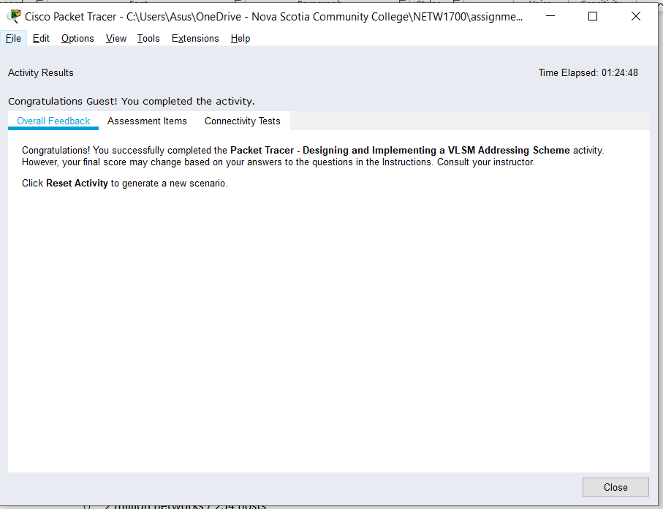

### SCREENSHOT 1 OF ACTIVITY 8.2.1.4

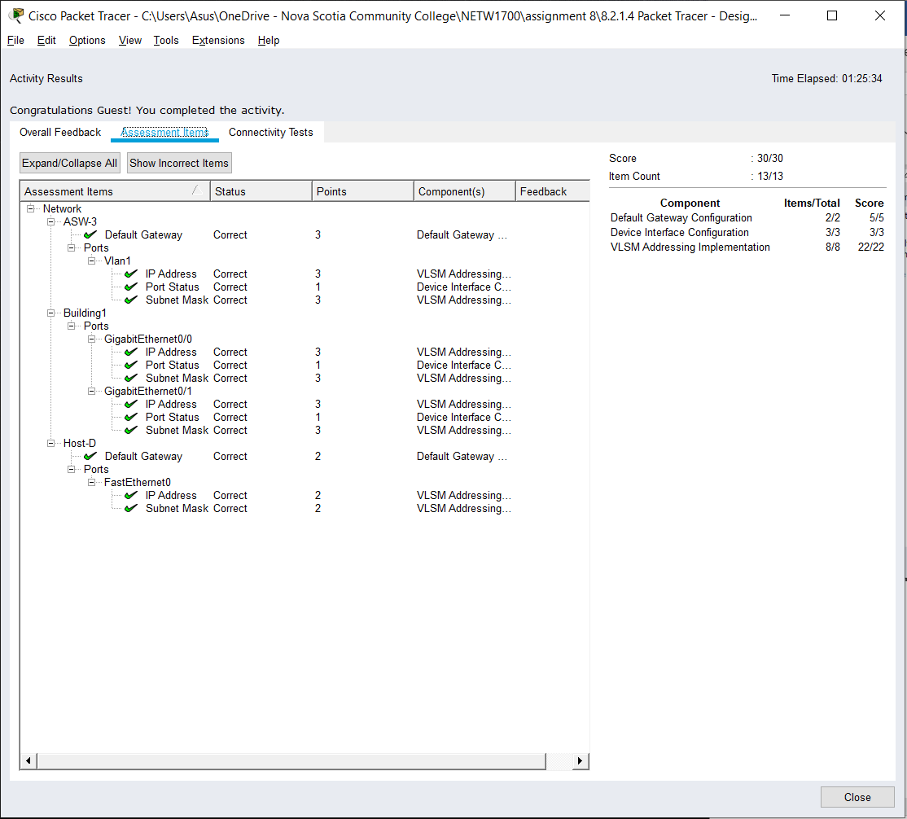

### SCREENSHOT 2 OF ACTIVITY 8.2.1.4

# Question 6

## Activity 8.3.1.4

**ADDRESSING TABLE**

|  |  |  |  |
| --- | --- | --- | --- |
| **Device** | **Interface** | **IPv6 Address** | **Link-Local** |
| R1 | G0/0 | 2001:DB8:ACAD:00C8::1/64 | FE80::1 |
| G0/1 | 2001:DB8:ACAD:00C9::1/64 | FE80::1 |
| S0/0/0 | 2001:DB8:ACAD:00CC::1/64 | FE80::1 |
| R2 | G0/0 | 2001:DB8:ACAD:00CA::1/64 | FE80::2 |
| G0/1 | 2001:DB8:ACAD:00CB::1/64 | FE80::2 |
| S0/0/0 | 2001:DB8:ACAD:00CC::2/64 | FE80::2 |
| PC1 | NIC | Auto Config | |
| PC2 | NIC | Auto Config | |
| PC3 | NIC | Auto Config | |
| PC4 | NIC | Auto Config | |

Part 1: Step 1:

**SUBNET TABLE**

|  |  |
| --- | --- |
| **Subnet Description** | **Subnet Address** |
| R1 G0/0 LAN | 2001:DB8:ACAD:00C8::0/64 |
| R1 G0/1 LAN | 2001:DB8:ACAD:00C9::0/64 |
| R2 G0/0 LAN | 2001:DB8:ACAD:00CA::0/64 |
| R2 G0/1 LAN | 2001:DB8:ACAD:00CB::0/64 |
| WAN Link | 2001:DB8:ACAD:00CC::0/64 |

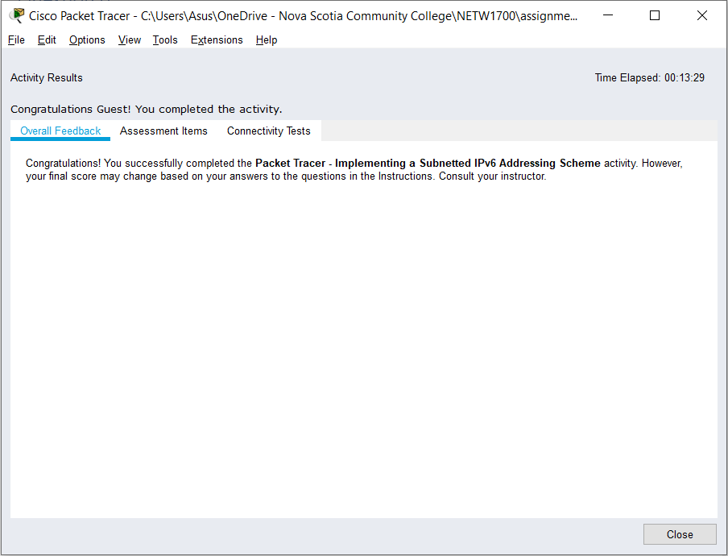

### SCREENSHOT 1 OF ACTIVITY 8.3.1.4

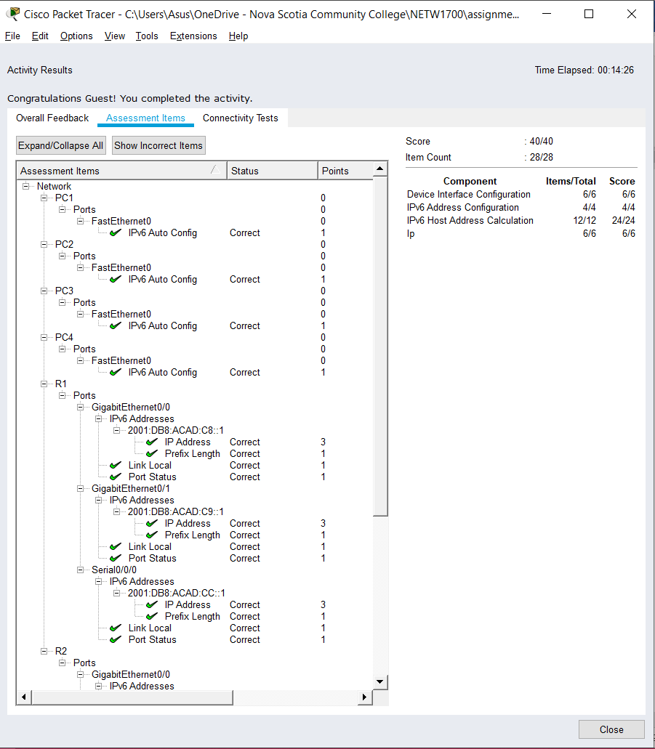

### SCREENSHOT 2 OF ACTIVITY 8.3.1.4

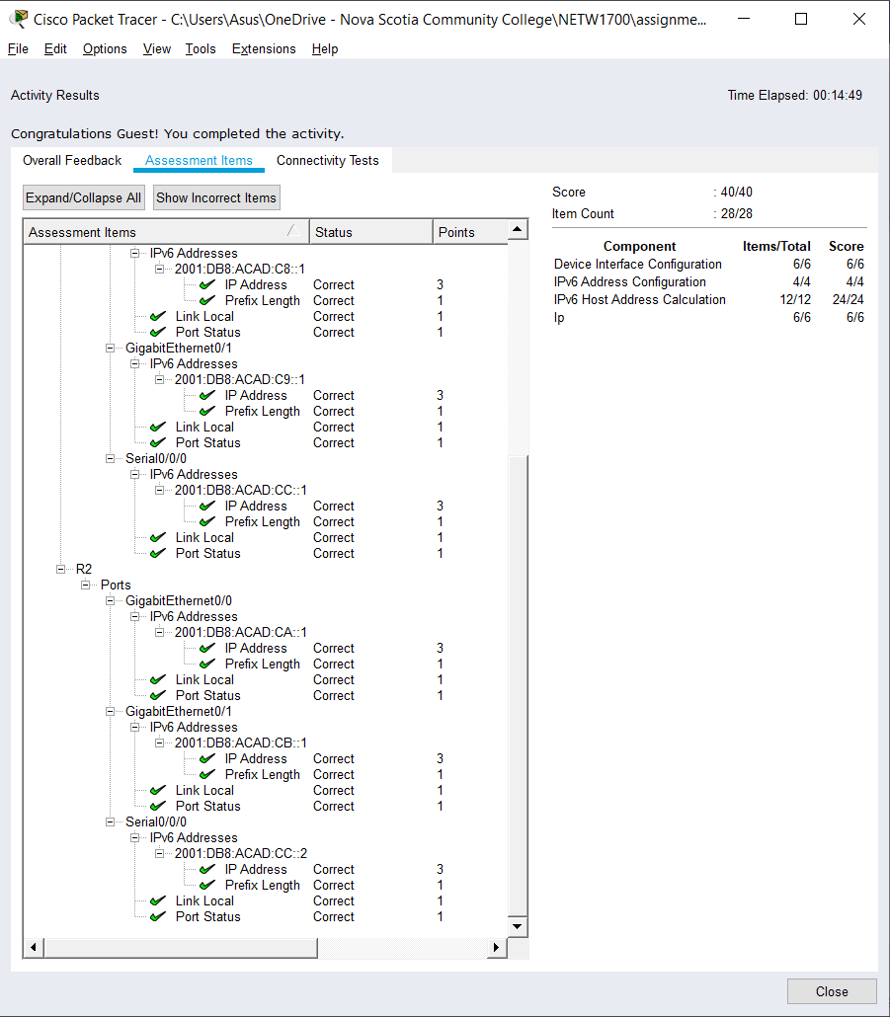

### SCREENSHOT 3 OF ACTIVITY 8.3.1.4

# Question 7

## Activity 8.4.1.2

**ADDRESSING TABLE**

|  |  |  |  |  |
| --- | --- | --- | --- | --- |
| **Device** | **Interface** | **IPv4 Address** | **Subnet Mask** | **Default Gateway** |
| **IPv6 Address/Prefix** | |
| Branch-A | G0/0 | 172.20.16.1 | 255.255.254.0 | N/A |
| G0/1 | 172.20.18.1 | 255.255.255.0 | N/A |
| G0/2 | 172.20.31.254 | 255.255.255.252 | N/A |
| Branch-B | G0/0 | 2001:DB8:FADE:00FF::1/64 | | N/A |
| G0/1 | 2001:DB8:FADE:0100::1/64 | | N/A |
| G0/2 | 2001:DB8:FFFF:FFFF::2/64 | | N/A |
| PC-A1 | NIC | 172.20.17.254 | 255.255.254.0 | 172.20.16.1 |
| PC-A2 | NIC | 172.20.18.254 | 255.255.255.0 | 172.20.18.1 |
| PC-B1 | NIC | 2001:DB8:FADE:00FF::10/64 | | FE80::B |
| PC-B2 | NIC | 2001:DB8:FADE:0100::10/64 | | FE80::B |

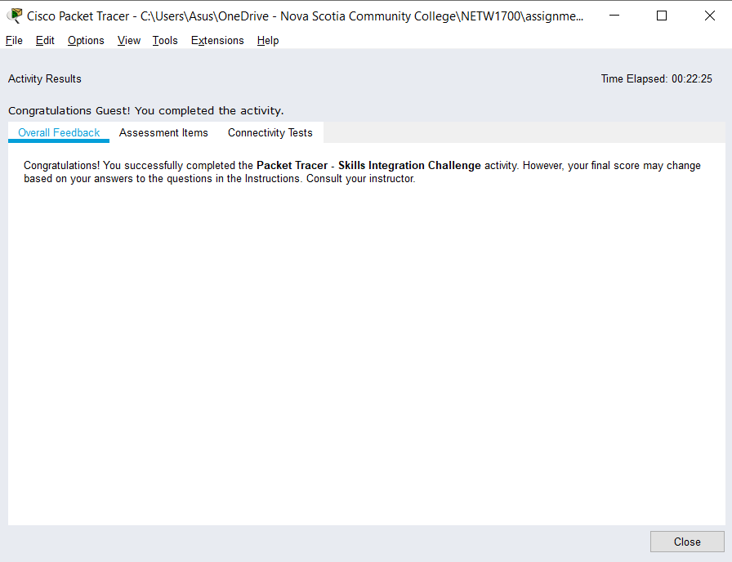

### SCREENSHOT 1 OF 8.4.1.2

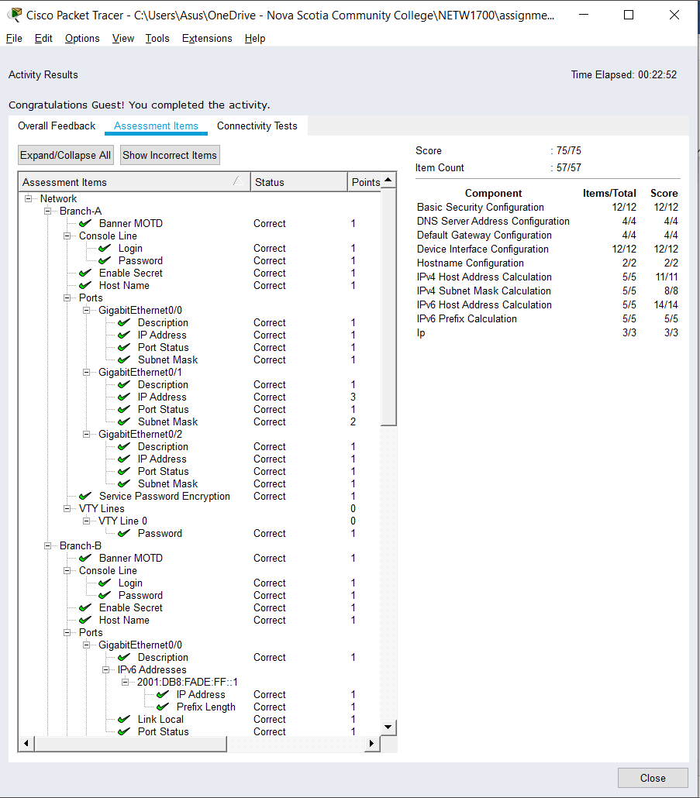

### SCREENSHOT 2 OF 8.4.1.2

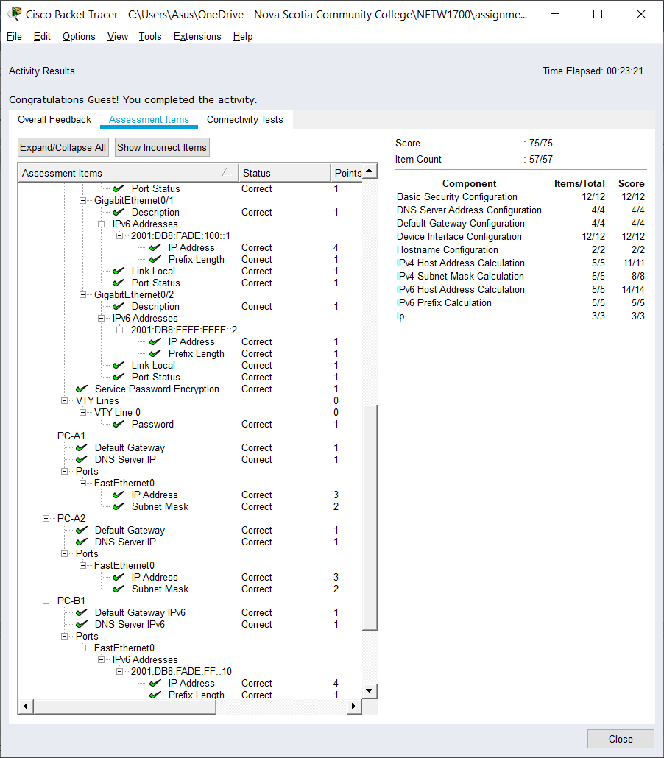

### SCREENSHOT 3 OF 8.4.1.2

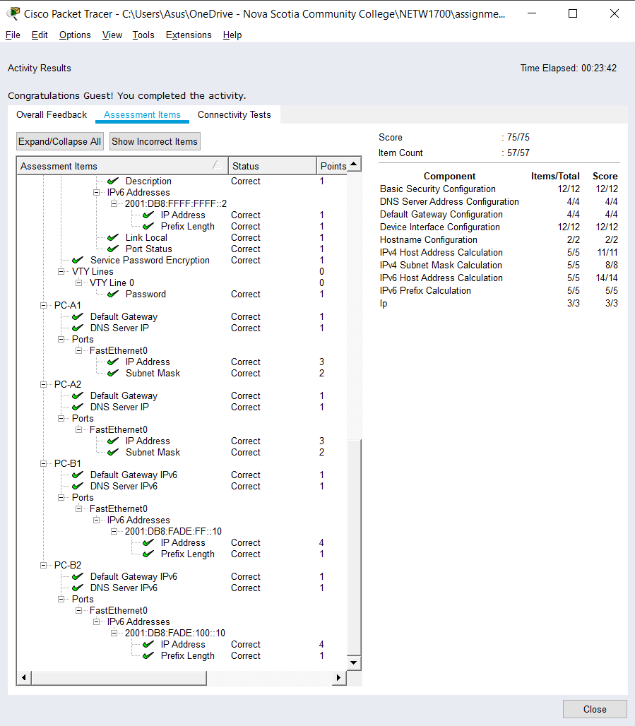

### SCREENSHOT 4 OF 8.4.1.2

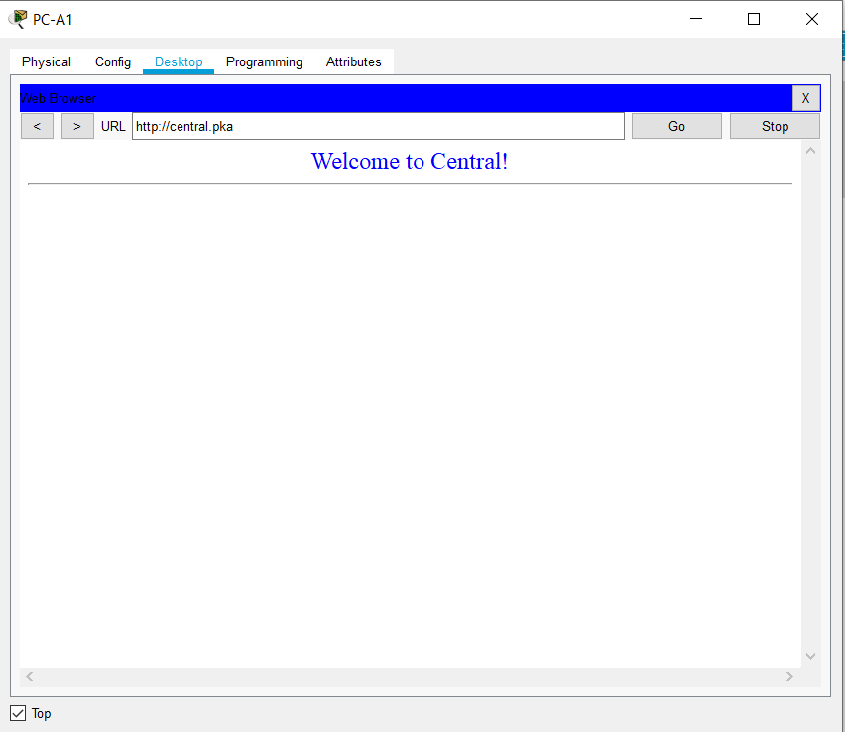

### SCREENSHOT 5 OF 8.4.1.2

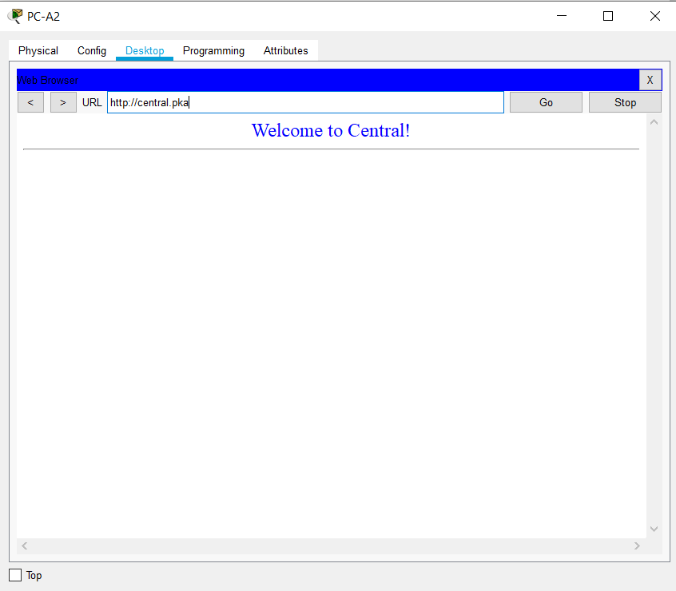

### SCREENSHOT 6 OF 8.4.1.2

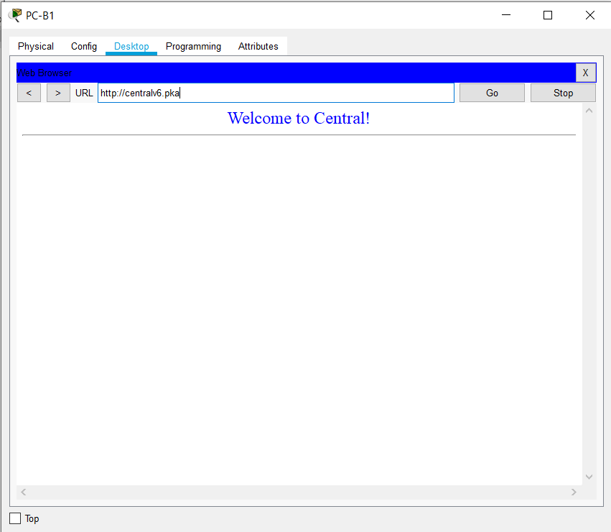

### SCREENSHOT 7 OF 8.4.1.2

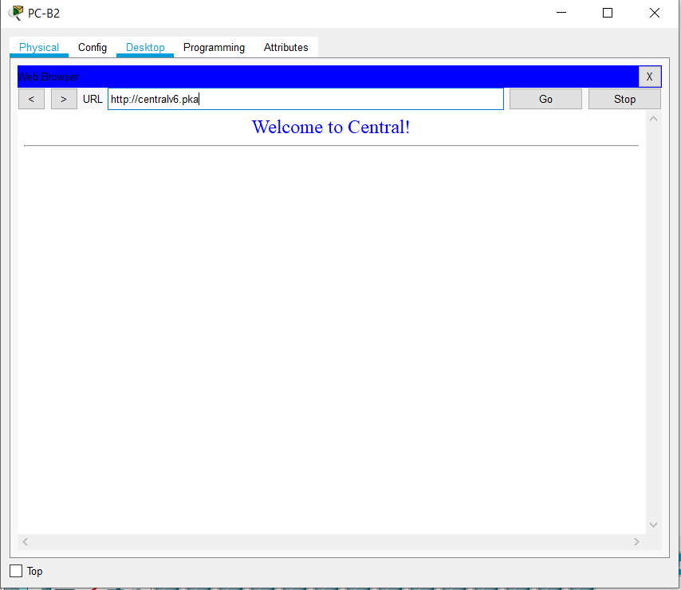

### SCREENSHOT 8 OF 8.4.1.2

# References

Cisco. (n.d.). *Chapter: Configuring Static Routing*. Retrieved October 30, 2019, from Cisco: https://www.cisco.com/c/en/us/td/docs/switches/datacenter/nexus3000/sw/unicast/503_u1_2/nexus3000_unicast_config_gd_503_u1_2/l3_route.html

Cisco Networking Academy. (n.d.). *Introduction to Networks, Chapter 2: Configure a Network Operating System*. Retrieved October 10, 2019, from Cisco Networking Academy: https://static-course-assets.s3.amazonaws.com/ITN6/en/index.html#2

Cisco Systems, Inc. (2010, April). *Cisco IOS Configuration Fundamentals*. Retrieved from Cisco: https://www.cisco.com/c/en/us/td/docs/ios/fundamentals/command/reference/cf_book.pdf

# 

# Appendix

## Appendix A – Cisco Commands Tool Kit[3]

**?** – this command will show the list of all the commands available for the specific mode you are currently in.

**(characters) ?** – this command is known as context-sensitive help. it will show the available commands in the current mode with the specific first characters you have entered. (example: **te?** in the user exec mode will show **te**lnet and **te**rminal, both starting with **te**.)

**banner motd “ ”** – this command will configure the message-of-the-day banner that will display when a user logs in to the switch.

**clock rate (rate)** – this command is used in DCE in serial link. This command configures the clock speed for the ink

**clock set (time and date)** – this command will allow you to set the time and date. (example: **clock set 15:00:00 july 11 2019)**

**copy startup-config flash –** this command will save the startup configuration to the flash memory. The flash memory is good to use as a back up.

**copy running-config startup-config** – this command will save the running configuration to the startup configuration.

**config terminal** – this command will open the global configuration mode.

**description Link to (server name)** – to describe the interface of the specified server.

**enable** – this command will open the privileged exec mode and will give additional commands.

**enable password** – this command followed by a password will set that same password for the privileged exec mode.

**enable secret** – this command followed by a password will set an ***encrypted*** password for the privileged exec mode.

**exit** – this command will exit the current mode.

**Flash –** this command will boot the router from Flash memory

**ip default-gateway –** this command will set the default gateway

**hostname** – this command followed by the name you want the hostname to be will change the hostname to what you want it to be.

**interface** – followed by the interface you want to configure will open that specific interface’s configuration mode.

EXAMPLES:

**interface fa0/0** - enter interface configuration mode for the FastEthernet interface

**interface s0/0/0** – enter interface configuration mode for the serial interface

**interface vlan <1-4094>**– you can use this command to configure an svi on a switch.

**ip address ­**– this command followed by the ip address and subnet mask you want will set the ip address and subnet mask to the entered values.

**ip route {ip-prefix | ip-addr ip-mask} {[next-hop | nh-prefix] | [interface next-hop | nh-prefix]} [tag tag-value [pref]][4] –** this command configures a static route and the interface for the static route.

EXAMPLE:

switch(config)# ip route 192.0.2.0/8 ethernet 1/2 192.0.2.4

switch(config)# ip route 192.0.2.0/8 192.0.2.10

**ipv6 unicast-routing –** in global configuration mode, this command will enable the router to forward IPv6 packets

**ipv6 address <ipv6 address> -** this command will manually assign a specific ipv6 address to an interface. Used in interface configuration mode. Insert no before ipv6 address to remove the address from an interface.

**ipv6 address <link local address> link-local-** this command manually assigns a specific link-local address to an interface and enables IPv6 processing on an interface. Used in interface configuration mode. Insert no before ipv6 address to remove the address from an interface.

**line** – this command will configure a terminal line.

**line console 0** – this command will open the line console configuration mode.

**line vty 0 15** – this command will open the virtual terminal configuration mode.

**login** – this command will enable password checking

**no shutdown** – this command enables an interface.

**password** – this command will set a password.

**ping** – this command will send a request to the destination and wait for the response. this is good for checking network connectivity.

**service password-encryption** – this command in the global config mode will encrypt all unencrypted passwords in the configuration file.

**show interface** – this command will display the status of the interfaces.

**show ip interface** – this command will display the configuration and status of the ip protocol.

**show ip interface brief** – this command gives a summary of the status and IP addresses of the interfaces

**show ip static-route[5] –** this command will display information about the static routes

**Show flash –** this command will show the files on the flash memory.

**show running-config –** this command will show the running configuration

**show startup-config** – this command will show all the startup configuration file.

**show clock** – this command will show the time and date.

***show?*** – this command would show all the show commands in the specific mode you are currently in.

1. (Cisco Networking Academy, n.d.)
2. (Cisco Systems, Inc., 2010)
3. References and sources from (Cisco Systems, Inc., 2010)
4. Referenced from: (Cisco, n.d.)
5. Referenced from: (Cisco, n.d.)